**Back to School Social Story**

**To stop people from sharing their germs and getting sick my school was closed.**

**I had to stay at home and stay safe.**

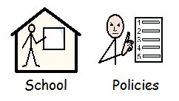**The Government who are in charge say it is safe for me to go back to school.**

**When I go back to school some things will be the same and some things may be different.**

**Things that will be the same –**

**The school building (add photo here)**

**The adults who work at school (add photo of familiar adults)**



**The children**

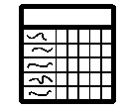

**My timetable**

**The way I travel to school (add photo/ symbol of appropriate transport)**

**Things that might be different –**

**Not all of my friends will be at school at the same time as me. This is ok.**

**My day might be shorter and I may not go to school every day. This is ok.**

**Here is a calendar showing which times and days I am going to go to school. If this changes my teacher and my parent/s will change my calendar (insert calendar here)**

[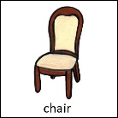](https://www.google.com/url?sa=i&url=http://www.mypecs.com/pecs_163/chair.aspx&psig=AOvVaw2rAbxlI55kAgoFUFPUnzlz&ust=1589463851373000&source=images&cd=vfe&ved=0CAIQjRxqFwoTCKjI0L38sOkCFQAAAAAdAAAAABAE)**I might sit in a different seat. My teacher will show me where to sit. This is ok.**

[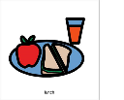](https://www.google.com/url?sa=i&url=https://boardmakeronline.com/Activity/2858072&psig=AOvVaw3zIquPo9qCY29HDmlask2j&ust=1589464065065000&source=images&cd=vfe&ved=0CAIQjRxqFwoTCNjol579sOkCFQAAAAAdAAAAABAD)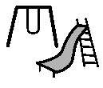**I might have different lunch and playtimes. This is ok.**

**There might not be assemblies.**

[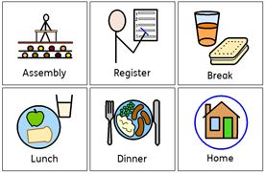](https://www.google.com/url?sa=i&url=https://www.pinterest.co.uk/pin/358317714083604816/&psig=AOvVaw2u_joukwfzaTTvf_H7TCjS&ust=1589464192760000&source=images&cd=vfe&ved=0CAIQjRxqFwoTCLjm9N39sOkCFQAAAAAdAAAAABAD)

**Sometimes change makes us feel worried or sad, that’s ok.**

**Everyone feels worried sometimes.**

**If you are worried you can tell someone who cares for you, a teacher or someone you live with. They will listen to you and help you to feel less worried.**

[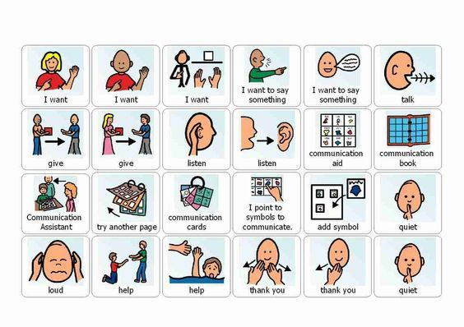](https://www.google.com/url?sa=i&url=https://www.pinterest.com/pin/34269647150010303/&psig=AOvVaw0IxzF1uKUKxZ_Px9jY7Yzu&ust=1589464396110000&source=images&cd=vfe&ved=0CAIQjRxqFwoTCKiVt8X-sOkCFQAAAAAdAAAAABAD)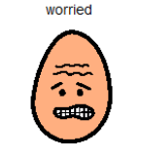

**All children need to go to school to learn and practice new things. It is good to go to school.**

**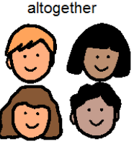****When the government says it is ok schools will start to go back to normal with all my friends and teachers coming to school every day. The adults will tell me when this is going to happen. It is ok, it is good to go to school.**