Aims
Our SEND Information Report aims to:
- set out how our school will support and make provision for all our children and young people (CYP). As a specialist provision all CYP have special educational needs and disabilities (SEND) and an Education and Health Care plan (EHCP)
- explain the roles and responsibilities of everyone involved in providing for our CYP
Our mission is to enable CYP to be successful, creative, lifelong learners participating in a journey of self-discovery through the Trust vision of ‘Achievement through caring’. It is our belief that all CYP have the right to a great education, full of opportunities and new experiences that fit hand in hand with traditional values around behaviour, manners and respect.
We are committed to providing a rich and varied curriculum that finds the talent in everyone. It is our aim to develop a love for learning so that our young people are driven to seek educational experiences that both inspire and challenge them as they progress throughout the school, and beyond.
This means that all CYP needs are regarded as special and that the needs of all CYP will be addressed naturally within the school’s learning policy.

Legislation and guidance
This policy and information report is based on the statutory Special Educational Needs and Disability (SEND) Code of Practice and the following legislation:
- Part 3 of the Children and Families Act 2014, which sets out schools’ responsibilities for CYP with SEN and disabilities
- The Special Educational Needs and Disability Regulations 2014, which set out schools’ responsibilities for education, health and care (EHC) plans, SEND coordinators (SENDCos) and the SEN information report

Who can I talk to about my CYP’s difficulties with learning/Special Educational Needs or Disability?
Members of staff at Woodlands who have the SENDCo qualification are:

Sarah McLaughlin (Director SEND)
sarah.mclaughlin@wdl.mmat.co.uk


The strategic lead for SEND at Woodlands is:
Alice Arnold (Deputy Headteacher for Culture and Belonging)
alice.arnold@wdl.mmat.co.uk

Tel: 01939 232372

Alice is responsible for:
- coordinating all the support for all CYP and developing the school’s SEND Policy and action plans to make sure all CYP get a consistent, high quality response to meet their needs in school. This includes developing and monitoring the school’s graduated response of support for our CYP and supporting the assessment of progress and impact.
- ensuring the changes under the SEND Code of Practice 2015 are implemented in line with the school’s SEND Development Plan.
- ensuring that parents/carers are involved in supporting their CYP’s learning, kept informed about the support their CYP is getting, and involved in reviewing how they are doing.
- liaising with all the other people/professionals who may be coming into school to help support a CYP’s learning: Speech and Language Therapist, Educational Psychologist, Occupational Therapy Service, Sensory Inclusion Service etc.
- providing specialist support for teachers and support staff in the school so they can help CYP in the school achieve the best progress possible.
- evaluating, in conjunction with all relevant stakeholders, the effectiveness of the school’s SEND provision.
- applying for additional support and funding where necessary for our most vulnerable CYP.
- coordinating support staff to ensure the best support is given to the CYP.

Your CYP’s Class Teacher/Tutor(s) is responsible for:
- checking on your CYP’s progress and identifying, planning and delivering any additional help they may need (this could be things like targeted work, additional support) and sharing information with colleagues as appropriate.
- writing Person Centred Plans (PCP) and sharing and reviewing these with parents/carers at least once each term, and planning for the next term.
- completing Assess, Plan, Do and Reviews of CYP’ targets.
- ensuring that all staff working with a particular CYP in school are helped to deliver the planned work/programme for the CYP, so they can achieve the best possible progress. This may involve the use of additional adults, outside specialist help and specially planned work and resources, in addition to differentiated Quality First Teaching.
- ensuring that the school’s SEND Policy is followed in all classrooms and for all the CYP they teach.
- implementing recommendations from outside agencies.


The Headteacher, Julia Taylor is responsible for:

- the day-to-day management of all aspects of the school, this includes the support for students.
- giving responsibility to the strategic lead for SEND, SENDCos and class teachers but is still responsible for ensuring that your CYP’s needs are met.
- making sure that the Governing Body is kept up to date about any issues in the school relating to SEND.
- support the school strategic lead for SEND and SENDCos in terms of budgeting the SEND provisions.

The SEND Governor, is responsible for:
- making sure that the necessary support is made for any CYP who attends the school.
- challenging the school’s leaders to ensure ALL CYP are supported to reach their full potential.

How can I let the school know I am concerned about my CHILDs progress in school?

How will the school let me know if they have any concerns about my CHILD’s learning and progress?
Your child’s progress will be discussed with you at Parents’ Evenings and through weekly check in’s. If it is felt that your child would benefit from additional support, the school will set up a meeting with you to discuss this in further detail and to:
- listen to any concerns you may also have.
- plan any additional support for your child.
- discuss with you any referrals to outside professionals to support your child’s learning.

What are the different types of support available for CYP at Woodlands School?
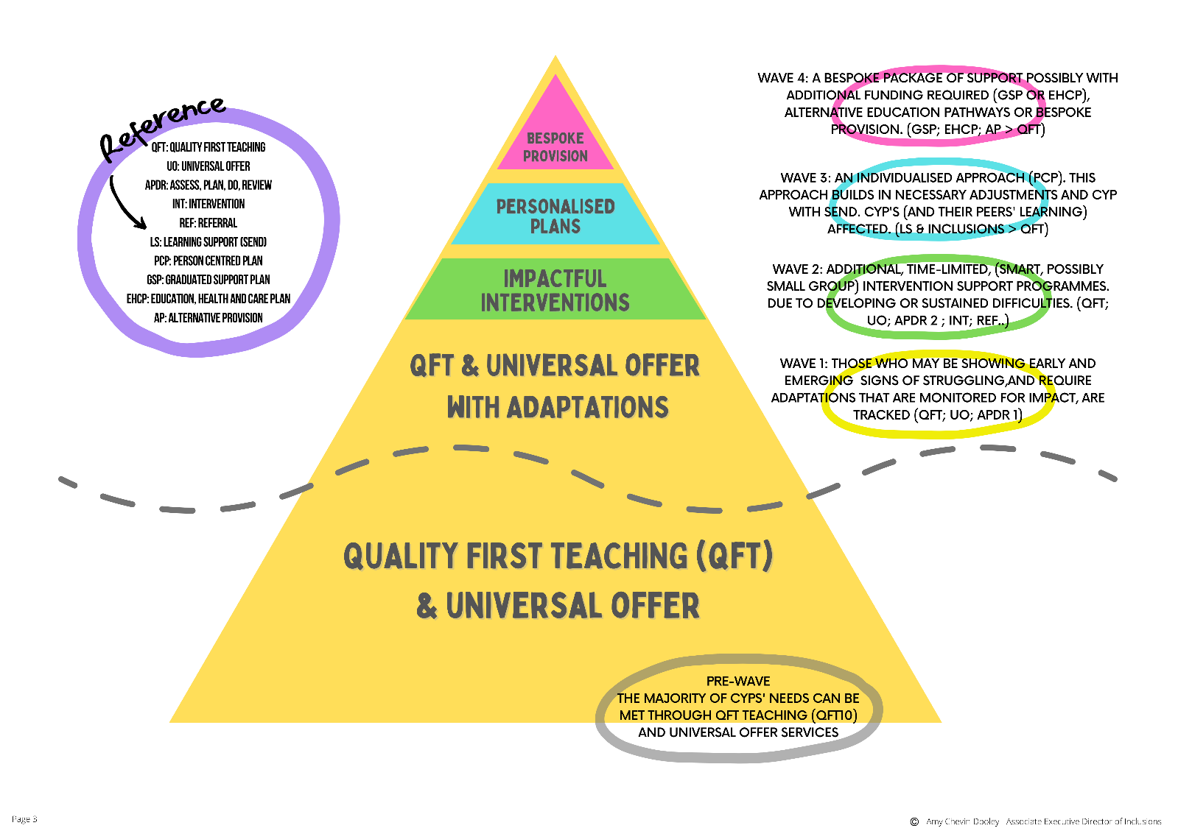
Support is provided along a graduated pathway at Woodlands School whereby the majority of CYP’s needs are met through our Universal Offer, including Quality First Teaching.
Where a CYP’s needs are greater than the Universal Offer, assess-plan-do-review cycles will identify the appropriate next steps to support the student to a provision that meets their need: specific, low-level intervention, high-level intervention or an extensive provision, via a bespoke provision offer.

How is extra support allocated to student and how do they move between the different levels?
- The Headteacher decides on the budget in consultation with the School Governors and SENDCo, taking into account the CYP already receiving support, the CYP needing extra support and the CYP who have been identified as not making as much progress as would be expected.
- If appropriate, CYP may also be part of targeted intervention groups to address particular needs.
- All resources and support are reviewed regularly and changes made as needed.

Who are the other people providing services to student with SEND at woodlands?

What training do staff have to help them meet the needs of CYP with SEND?
- The SENDCo supports class teachers in planning to ensure needs of all CYP are met in the classroom.
- Woodlands has a training plan for all staff to improve teaching and learning for all student and this includes whole school training on SEND such as ASD, speech and language difficulties, etc.
- Individual members of staff also attend training courses run by outside agencies that are relevant to the needs of specific student in their class.

How will teaching be adapted for my CHILd?
- Class teachers plan lessons taking into account the needs of all CYP in their class.
- Specially trained teaching assistants can adapt the teacher’s planning further to meet the needs of individual CYP, if needed.
- Your CYP may also be part of an intervention group to target a particular area of learning i.e. phonics or handwriting.
- If appropriate, particular resources may be provided to help your CYP’s learning i.e. writing slope, pencil grips, lap cushion, fidget toy.
- Planning and teaching will be adapted on a daily basis if needed to meet your CYP’s learning needs.

How do we evaluate the effectiveness of the provision made for CYP?
- All CYP have their progress and attainment tracked throughout the year. Currently there are three main dates throughout the year where data is collected.
- CYP have termly reviews of their PCPs, involving parents/carers and CYP.
- Wave Review meetings are held regularly throughout the year to identify CYP that are not making expected progress and the support being put in place for these CYP.
- Targeted interventions are put into place for CYP who are not making expected progress and interventions are tracked and analysed to evaluate the impact.
- Regular meetings with staff, parents/carers and CYP ensure that interventions and additional support have the desired impact on CYP’s progress, attainment and personal development.

How are CYP facilitated to engage in activities?
- We ensure that all CYP have equal opportunities.
- All our CYP are encouraged to join in a large range of extra-curricular activities during the school day.
- We ensure that our school environment is adjusted and adapted to meet the specific needs of any individual student.

How do we support the emotional and social development of our CYP?
The wellbeing of all our CYP is paramount.
- Our strategic lead for SEND and SENDCos work very closely with the designated safeguard leads in school to ensure that all CYP are well supported in their wellbeing.
- Our PSHE curriculum supports the needs of all CYP.
- Targeted intervention groups are made available when needed.
- Our Anti-Bullying policy outlines the school’s approach to all instances of bullying. All CYP are taught about bullying and how to prevent it.
- Clear and consistent behaviour policy application promotes positive behaviour and is used across school, and also promoted during assembly time.

How will we measure the progress of your CYP in school?
- Their progress will be formally reviewed every term by the class teacher.
- Woodlands uses a variety of assessments to assess and monitor attainment and progress in student’s learning.
- CYP have a Pupil Centred Plan (PCP), which will be reviewed with you each term.
- CYP PCPs and assessment data are monitored by the SENDCos and Deputy Headteacher each term to ensure learning approaches are appropriate and CYP are making progress.
- EHCPs are formally reviewed with you at an Annual Review with all adults involved in your CYP’s education.

How is WOODLANDS accessible to CYP with Physical needs?
- Woodlands School does, in parts, have two levels but every endeavour will be made to ensure your CYP can access a classroom and where possible classes are on the ground floor with appropriate access.
- We ensure that equipment used is accessible to all CYP regardless of their needs.

How do we work together with CYP?
- We value the opinion of all our CYP and allow regular opportunities for CYP to discuss their learning. CYP are involved in peer and self-assessing regularly and respond to marking to improve their learning.
- PCPs are created and reviewed with the CYP termly.
- CYP participate in setting targets.

What expertise are available within our school?
Members of staff have a vast range of skills, including:
- Mental Health First Aid practitioners
- Emotional Literacy Support Advisors
- Play Therapy
- Drawing and Talking
- Emotion Coaching
- Cool Kids
- Attachment Training – Levels 1, 2 and 3
- Supporting CYP with Dyslexia
- Fresh Start/Ruth Miskin (KS3)
- Team Teach
- Zones of Regulation
- Autism Education Trust
- Social Skills
- Precision Teaching
- ELKLAN

SEND Local Authority – Local Offer
www.shropshire.gov.uk/the-send-local-offer/

Further support is available from The Shropshire Information, Advice and Support Service (Shropshire IASS) which provides free, confidential and impartial information, advice and support regarding special educational needs and disabilities (SEND), including health and social care. Contact Shropshire IASS on 01743 280019. The referral line is manned Monday to Friday, 10am till 4pm.
Email address: iass@shcab.cabnet.org.uk Website: http://www.cabshropshire.org.uk/shropshire-iass/
Provision for CYP

Woodlands School Provision Map
 | All CYP have access to: | Additional strategies for CYP may include (when appropriate):
Cognition and Learning | - Quality first teaching  - Adapted teaching  - Flexible teaching arrangements i.e., seating  - Stimulating curriculum  - Different learning styles | - Focused teaching on individual targets  - In class TA support for English and Maths to focus on basic skills (small group or 1:1)  - Multi-sensory activities i.e., for spelling  - Extra ‘thinking time’ to organise thoughts and complete work  - Additional reading with an adult  - Additional use of ICT (information communication technology)  - Visual timetables  - Scribe for writing  - Activities to develop memory skills  - Use of resources to focus concentration i.e., lap pads, fidget toys  - 1:1/small group teaching for phonics  - Intervention groups i.e., Read, Write Inc, Catch Up Literacy  - Individual support from LSAT, Educational Psychologist and ASD Outreach service  - Precision Teaching
 | All CYP have access to: | Additional strategies for CYP may include (when appropriate):
Sensory and Physical | - Quality first teaching  - Adapted teaching  - Flexible teaching arrangements i.e., seating  - Stimulating curriculum  - Different learning styles  - ‘5 a day ’activities daily  - PE curriculum  - School games teams | - Use of resources such as pencil grips, writing slopes, different paper types, larger fonts, alternative PE equipment  - Additional use of ICT  - Individual support from Sensory Inclusion service, Occupational Therapy, Physiotherapy

 | All CYP have access to: | Additional strategies for CYP may include (when appropriate):
Communication and Interaction | - Quality first teaching  - Adapted teaching  - Flexible teaching arrangements i.e., seating  - Stimulating curriculum  - Different learning styles  - High focus on speaking and listening activities | - Visual timetables  - Multi-sensory activities  - Peer support to model language  - Additional use of ICT  - Intervention groups i.e., social skills group, Talk Boost  - Playground support  - Individual support from Speech and Language Therapist, LSAT or Educational Psychologist
 | All CYP have access to: | Additional strategies for CYP may include (when appropriate):
Social, Emotional and Mental Health | - Quality first teaching  - Adapted teaching  - Flexible teaching arrangements i.e., seating  - Stimulating curriculum  - Different learning styles  - Whole school behaviour policy – rewards and sanctions  - Whole school and class rules  - Focused PSHE curriculum  - Head teacher awards and other strategies for recognition  - Positions of responsibility  - Use attachment and trauma informed approaches, i.e. PACE, Unconditional Positive Regard.  - Regulation spaces  - Co-regulation support  - Emotion Coaching  - Facilitated and supervised social times | - Personalised timetables  - Individual support from Educational Psychologist, BeeU etc.  - ELSA sessions  - Drawing and Talking  - 1:1 mentoring sessions  - Counselling sessions  - Nest provision  - Risk Reduction intervention  - Play Therapy  - Mental Health Practitioner

