Woodlands



Post-16 Information

2023-24

Woodlands Post 16 Programme

Young people are expected to remain in education until the age of 18 to be supported to achieve their best possible educational outcomes with the resources available, in preparation for their adult life.

During Years 10 and 11, Woodlands pupils will be offered a variety of activities, advice and guidance to help support successful transition to Post 16 Education or Training.

These could include:

Meetings with Careers Lead

Careers Action Plan

Independent Careers Advice

Employability sessions with Job Centre Plus

Support with writing a CV/Personal Statement

Mock Interviews

Information about apprenticeships

Support with applications for college/other Post 16 options

Information about open evenings/events

College Taster Courses

Visits to employers/Work Experience

Individual Transition Programme

Post 16 Options Information

Information events for pupils leaving Year 11 in 2024

This virtual event will bring together all the leading providers of state sector post 16 education in the area (including local Training Providers).

The event starts with a live stream presentation covering all the important aspects of transitioning from school to further education and exploring the differences between the different qualifications that are open to you.

This presentation will then be followed by a live Q&A session and then access to the interactive event map where you can ‘visit’ providers such as colleges and The Armed Forces and get more in-depth information on what they can offer you. The main presentation will also be available to watch on-demand again after the event.

The Post 16 Options Roadshow 2023: Virtual Expo is available online until Wednesday 31st July 2024.

You must pre-register for access to the Expo using this link:
Post 16 Options Roadshow 2023: Virtual Expo Tickets, Sat 4 Nov 2023 at 18:30 | Eventbrite

Post 16 Options in Shropshire
Colleges / Post 16 providers | Shropshire Council
Colleges and training providers offer bespoke study programmes and specific student support for young people with additional needs, special education needs and/or disabilities.

Colleges and training providers provide full time and part time study programmes with a range of study options, including vocational, academic (GCSEs and A levels), supported internships and traineeships. All study programmes will include enrichment activities.

They also offer apprenticeships and progression to some local higher educational study. Many colleges offer onsite training, working in environments that are open to the public, such as restaurants or hair and beauty salons.

Below is a summary of the colleges and training providers in and close to the border of Shropshire.
Shrewsbury Colleges Group

North Shropshire College (Oswestry Campus)

North Shropshire College (Walford Campus)

Reaseheath College, Nantwich

Vocational entry requirements

Level 1

A one year course offered within vocational skills subject areas. Often the starting point, regardless of previous academic qualifications and experience, as you need to develop the trade skills. It is possible to work at your own pace and develop Level 2 skills within the first year. Progression to Level 2 as a second year is required for employment.

Level 2

Usually one year and suitable if you have achieved some GCSEs at grades 3-1 or have passed a Level 1 qualification. For some subjects this is the first level based on skill development. Progress to Level 3 courses or an Apprenticeship.

Level 3

Could either be A Level, BTEC Diploma, Subsidiary or Extended Diploma. Normally taken over two years and are suitable if you have gained four or five more GCSEs at grade 4 or above or have passed a Level 2 qualification with an overall merit or distinction with either Maths or English at grade 4 or above. Higher entry requirements needed for some subject areas. However a Level 3 can be one year if it’s progression from Level 2 in trade and skill areas.

Shrewsbury College

Vocational courses
Vocational courses will give you the knowledge, skill, work experience and qualifications to progress to a higher education course at university or at college, to an Apprenticeship or into full-time employment.
They will also provide you with the employability skills that will give you a head start in your chosen career.
Vocational courses are almost all taught at the London Road campus.
Art vocational courses are all taught at the English Bridge campus.

Open Evenings
The next Open Evening (Vocational) for London Road Campus will take place on Thursday 22nd February from 4.30pm – 6.30pm.
Use this link to register:
Open Evening Spring 2024: London Road Campus #2 Tickets, Thu 22 Feb 2024 at 16:30 | Eventbrite

Taster events, where you can find out more about individual courses are available in the Autumn Term and online throughout the year
Taster Events (scg.ac.uk)

North Shropshire College

North Shropshire College - HLNSC

- Oswestry – offers a variety of vocational courses and BTEC qualifications. Professional cookery qualifications with the use of a commercial restaurant, hair and beauty with access to the commercial salon, construction, plumbing, electrical, business, IT, maths, English, early years, health, science and many more
- Walford (near Baschurch) - offers land-based courses, extensive facilities in equine, agricultural farming and an exotic animal care unit. The specialist independent living department offers independent living skills programmes. For more information please visit the college’s website.

Open Events are held throughout the year at both the Oswestry and Walford campuses. They are a great opportunity for prospective students and parents to come along to the College and see for themselves the fantastic facilities and learning resources on offer. Tutors and course leaders are available to discuss course options and to give course advice and information.

Open Event at Oswestry Campus

Saturday 3rd February 2024, 10am - 12pm

Book your place using this link:

North Shropshire College Open Event - Saturday 3rd February - HLNSC

Open Event at Walford Campus

Saturday 3rd February 2024, 10am – 12.30pm

Book your place using this link:

Walford College Open Event - Saturday 3rd February - HLNSC
Reaseheath College

Reaseheath College | leading land-based college

Reaseheath College, Nantwich provides further education courses in areas such as Animal Management, Agriculture, Equine, Motor Vehicle, Agricultural Engineering, Sport and Outdoor Adventure, Food and more.

Course Open Events
An excellent opportunity for you to discover the many courses we offer. You will also have the chance to speak to our specialist course staff and get information about finance, transport, accommodation & learner support.

- Saturday 13 January 2024
- Saturday 10 February 2024
- Saturday 23 March 2024
- Saturday 20 April 2024
- Saturday 8 June 2024

Bookings for the next open events are available here:

Experience Reaseheath | Reaseheath College

Apprenticeships

A handy guide to apprenticeships
Parent-Guide-Apprenticeships.pdf (publishing.service.gov.uk)
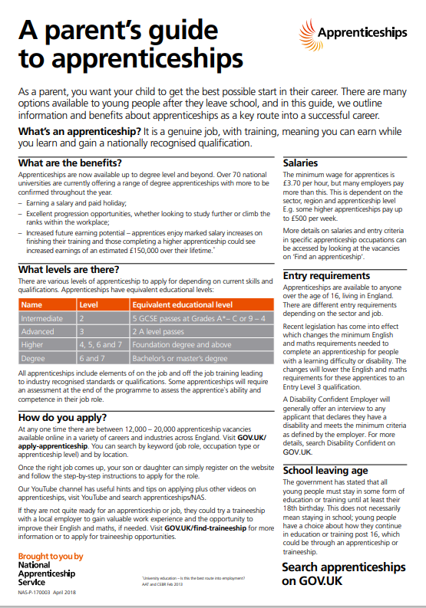
County Training

County Training – HLNSC
County Training are part of Herefordshire, Ludlow & North Shropshire College and deliver apprenticeships and work-based training across Shropshire, Telford & Wrekin and Herefordshire.
They are one of the largest employer-facing training providers in Shropshire, operating from several bases across the county including the Gateway Centre in Shrewsbury and training bases in Oswestry, Walford and Ludlow.
County Training also deliver adult learning programmes for the unemployed and those seeking to progress into further education or employment.
They work closely with employers and businesses of all types across the region, as well as other stakeholders such as local councils.

SBC Training
Training is delivered in dedicated workshops for a wide range of engineering skills, electrical installation and ICT. Other specialist areas include administration, management, marketing and health and social care.
Apprenticeships | Training Programmes | Shropshire (sbc-training.co.uk)

Local colleges also offer apprenticeships, but you must have a secured a post before you apply.

Alternative Providers
Reach for Inclusion
Reach Learning Centre (reachforinclusion.co.uk)

Within Reach is a Post 16 programme, supporting young people in their first steps towards adulthood. The programme offers a range of qualifications.

Crossbar
Crossbar Alternative Provisions | 1NSP1RE Programme
1NSP1RE+ is a bespoke course for SEN Post 16 learners. It includes guided work experience, life skills and SEMH support in order to build confidence for the next steps such as mainstream education, apprenticeships, employment or supported internships.

Really NEET
The Really Neet Project - The Really Neet Project
Really NEET promotes and supports the development of young people through Youth work, enabling them to have voice and influence in their education. Really NEET aims to ensure their educational offer is tailored to consider individual needs and aspirations.
Really NEET place a huge value on enrichment activities to improve learner experience and self-confidence. Activities can include quad-biking, rock-climbing, football and even a two-day residential. Qualifications available are NCFE Functional Skills English and Maths, and The Arts Award.
Further support and guidance

We hope this booklet helps give a clear picture of what Post-16 options are available.
We aim to keep you updated on progress throughout the year.

Please do not hesitate to contact us if you have any questions, or require further support and guidance at any point during the year.

elly.downing@wdl.mmat.co.uk
01939 232372

Other support
Enable
Home - Enable. Supported Employment Services (enableservices.co.uk)
Landau
Training & Learning - Landau
IASS
Shropshire Information Advice and Support Service – Citizens Advice Shropshire (cabshropshire.org.uk)

