Career of the Week

Christmas Elf (from elfhq.com)
Santa has millions of elves all over the world (not just at the North Pole). They are regular people with other jobs – everything from schoolteachers to scientists to truck drivers to students. Anyone out there could be an elf and you’d never know it.
There is no minimum or maximum age to be an elf. It does not matter where you live, what you wear, how you dress or even what you know to be an elf. You just need to believe in Santa and have a desire to serve other people in order to be an elf.
Santa has millions of elves working for him worldwide. Any person out there that you meet could be an elf and you would never know it. Elves are short and elves are tall. There are skinny elves and not-so-skinny elves. There are elves in every country of the world and they speak all kinds of languages. Anyone can be an elf!
All elves working for Santa know certain things. They believe certain things. They may look different, but they act the way Santa would have them act. That’s because they are taught and trained in the Art of Christmas, a way of knowing how and why Santa is the way that he is.
Here are the basics all tracker elves should know:
The Elf Code
(Insert photo here)
The Elf Oath
- Stand, put your right hand on your heart, raise your left hand and say out loud for all the world to hear:
- I, (your full real name), hereby take upon myself the sacred and secret elf name of Elf (your chosen elf name). In so doing I swear the following oath:
- I will be loyal to the Day of Christmas, always grateful for the blessings I receive and the joy I can give to others.
- I believe in Santa Claus, his mission and the sacred trust put in me as one of his Elves.
- I believe in Love and in giving it to others freely.
- I believe in Giving Anonymously.
- I believe in Others.
- I swear to Love, to Give, and to Believe in Others for the Rest of My Days.
- I dedicate my daily working endeavors to quietly giving to others in ways small and large:
- To always be merry.
- To always serve.
- To always seek for the happiness of other people.
- I pledge to Santa Claus my loyalty, my best efforts, and my relentless pursuit of service.
- In my duties I will be careful, judicious and confidential.
- I will remain completely anonymous.
- I will keep the secrets of Santa.
- From this time forward, I am known as Elf (your chosen elf name) and I wish the world a Merry Christmas.

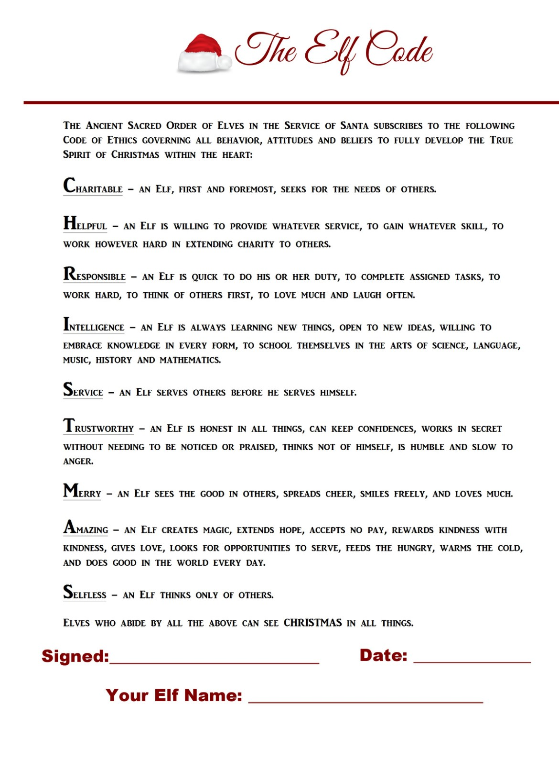

Job Description

Tracking Santa for Santa is the job of the Tracker Elf. Each Tracker Elf works from wherever they live in the world and sends in reports to North Pole Flight Command.
With enough elves working in this capacity, we ensure Santa gets around the world on time and returned safely to the North Pole.
A tracker elf is responsible for observing local conditions. These observations include weather, local ground conditions, the overall condition of roof tops and chimneys, and other items of interest to Santa and North Pole Flight Command.
Elves work year-round by following North Pole News and information relative to Operation Merry Christmas. Tracker elves report to an Elf Supervisor located in their sector. Elf Supervisors provide direction to all elves in the sector.
Job Responsibilities:

A tracker elf, whether a Freelance Elf or a North Pole Elf, is responsible for the following:
- Tracking Santa using Official North Pole News sources, trackers and maps
- Observe local weather, traffic conditions and general Christmas environment
- Inspect roofs, chimneys, yards, fences and potential obstacles
- Evaluate Christmas trees, stockings and decorations
- Report as required to North Pole Flight Command
- Be available for special elf projects

Qualifications:
- Unwavering belief in Santa
- Know and teach The Elf Code
- Take the Elf Oath and live by its principles
- Join the Ancient Order of Elves in the Service of Santa
- Possess a spirit that is can-do, positive, cheerful and never complains

