Schools are going to be completing Covid tests to keep everyone safe.

You will need to have a test in school. This doesn't mean you have Coronavirus, but you need to do the test just to check.

The Covid test will be done by (insert name of staff) in (insert name of room). The staff will be wearing a mask, visor and an apron so they might look different.

First, you will need to wash your hands with soap and water or hand santiser (delete as appropriate). Then blow your nose into a tissue and throw it away.
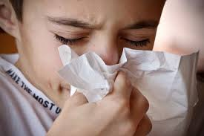
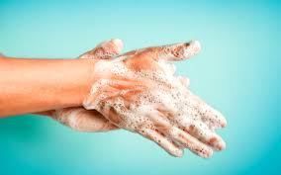

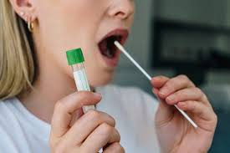
You will use a special white cotton bud called a swab on the back of your throat. You will need to open your mouth wide and say 'ahhhh'. You will put the swab inside your mouth and rub it on your tonsils for 10 seconds. This can feel a bit yucky, but will be over quickly!

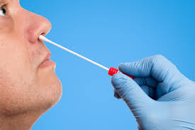
You will then put the swab into your nose and gently twist it, this may tickle a bit! You will take it out and put it in a special tube.

This is the end of the test, don't forget to wash your hands.

The test results come back in about 30 minutes.

(Insert staff name) will let you know the result. If it is positive, you will go to (insert name of room) and we can call (inset names of parent/carer) so you can go home.

If it is negative you will stay in school.

If you have any questions you can ask (insert staff name)

