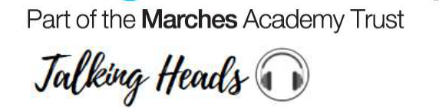
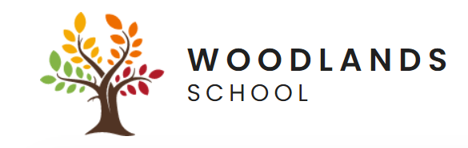


Friday 8th May 2026
Headteachers report of the week

This week has highlighted the incredible value of live work visits in bringing learning to life for our learners. Opportunities to visit real working environments allow learners to see first-hand how their skills, interests, and learning connect to the world beyond the classroom.

Learners had a fantastic opportunity to visit Vinci Construction at the Shrewsbury Hospital, where they experienced a live working site within a hospital setting. This inspiring visit gave learners valuable insight into careers in construction and the range of roles involved, combining practical activities with academic understanding to support future pathways.

We were also delighted to see learners enjoying a visit to Attingham Park, where they explored the natural environment, through a nature walk and spotting wildlife including deer and birds. This experience supported learning about nature and wellbeing while encouraging independence, observation and enjoyment of outdoor spaces.

By engaging with professionals on live sites, learners gain meaningful insight into different industries, develop confidence, and enhance their understanding of workplace expectations. These experiences support decision-making about future pathways and help learners build essential life and employability skills such as communication, teamwork, and problem-solving.

We are proud to offer such inspiring experiences and remain committed to providing practical, purposeful opportunities that motivate learners and prepare them for the future. I would like to thank our staff and external partners for their continued support in making these valuable experiences possible.

Best wishes

Jules

Acorns 3 have been enjoying the story Baker by the Sea
by Paula White

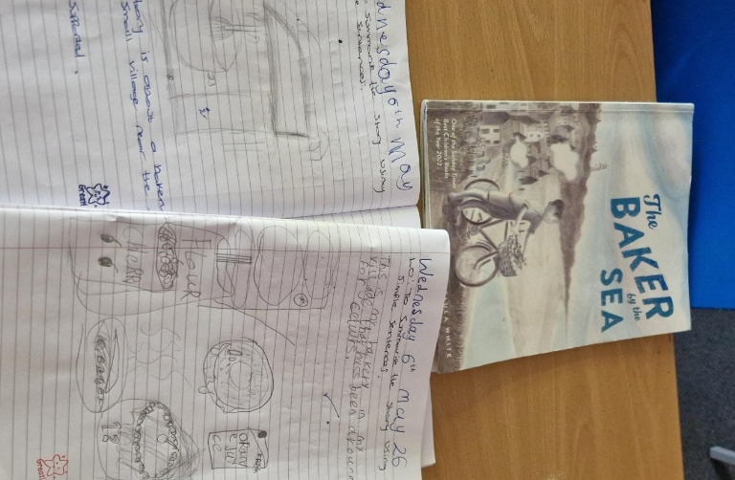
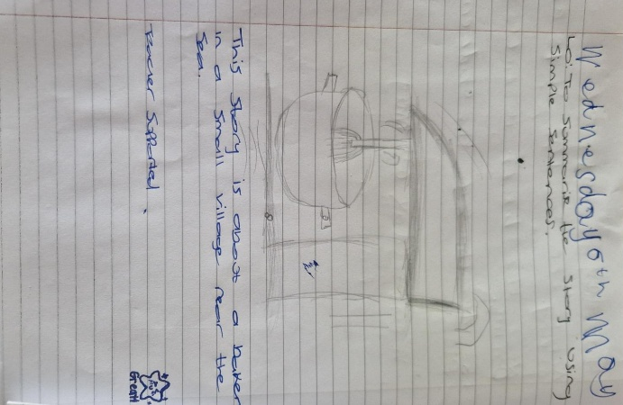
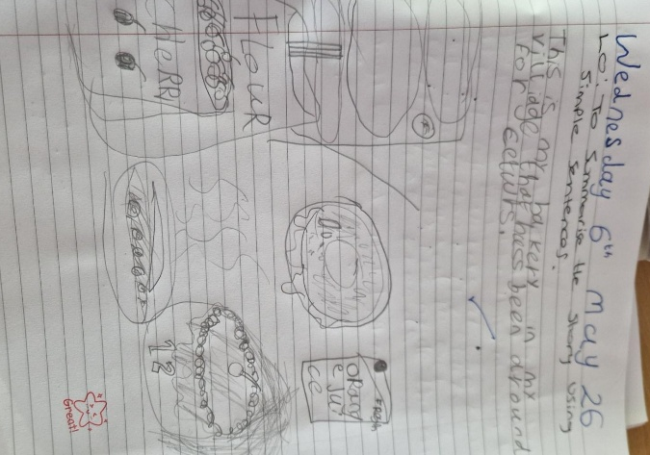

Learners took great pride in reading the book together and were able to confidently summarise the plot in their own words.
They then expressed their understanding creatively by drawing objects they associated with the story.
- Great work Acorns 3!

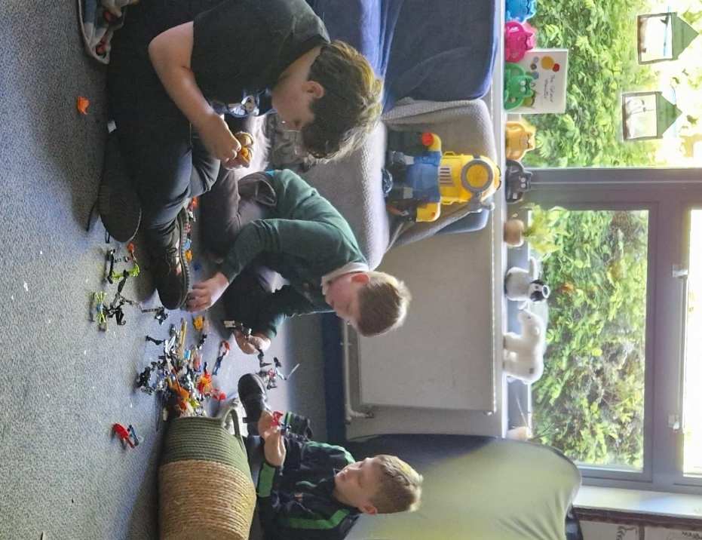
Primary thoroughly enjoyed their social time this week.

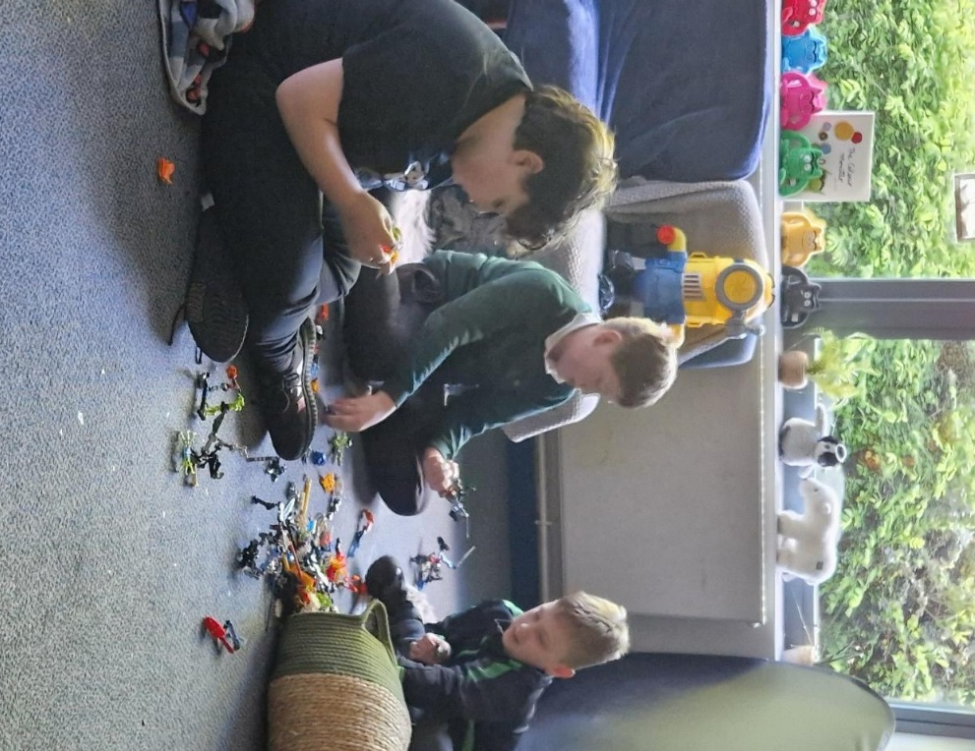
They used their imagination and teamwork skills to create impressive, unique builds using Meccano, showcasing creativity and excellent problem-solving skills.

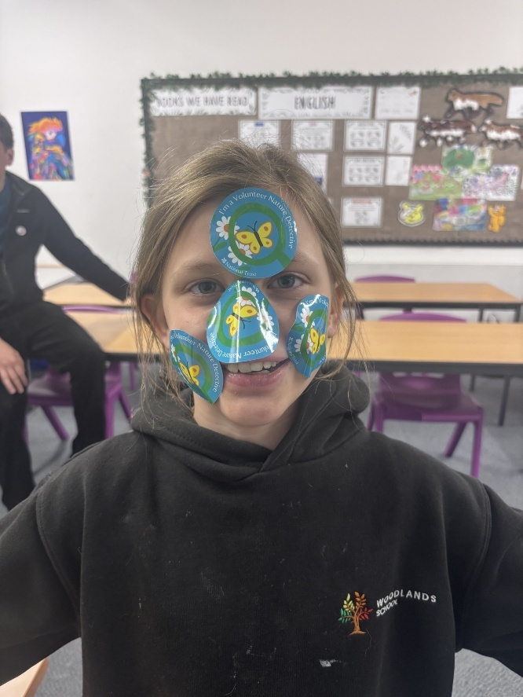
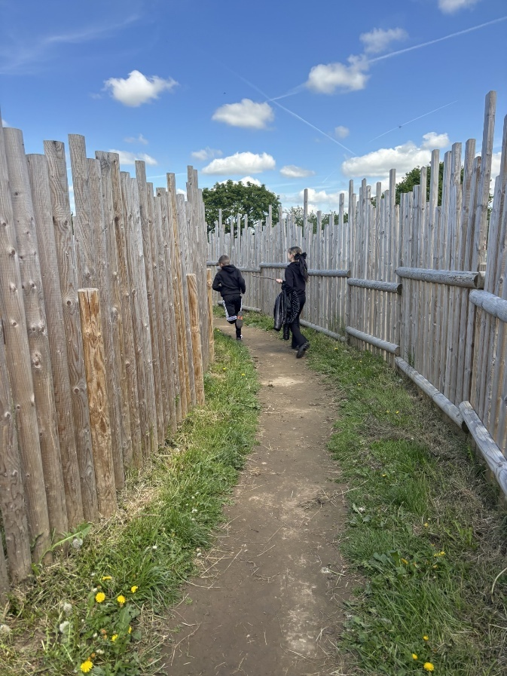
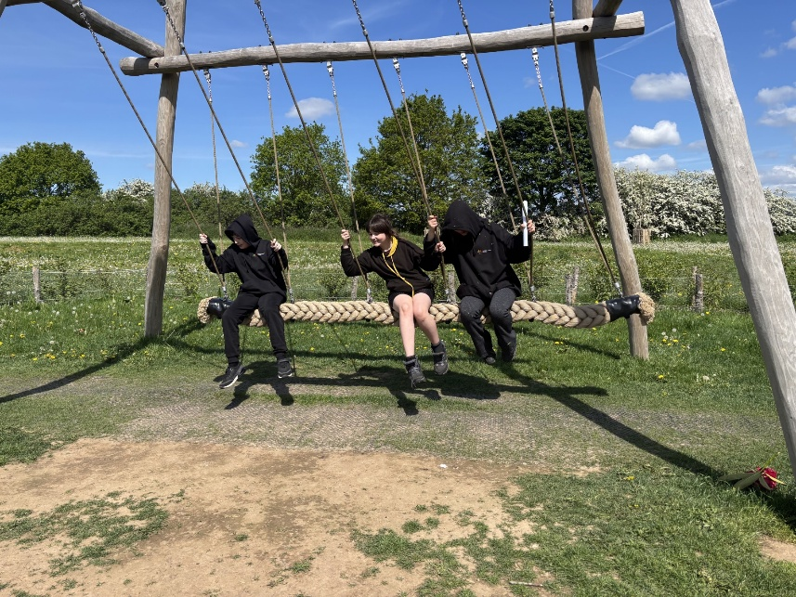
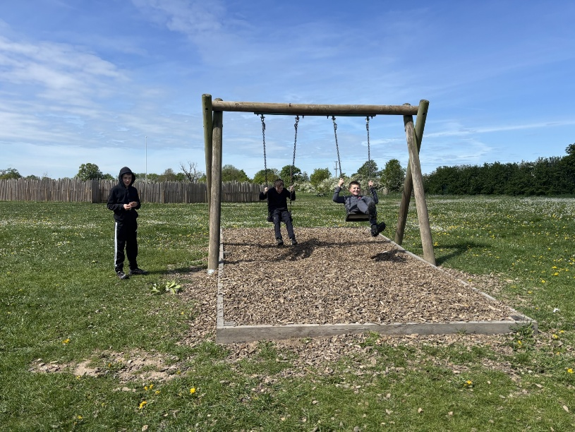
Learners had an amazing trip to Attingham Park this Wednesday. They enjoyed a nature hunt and walk and spotted the deer’s and birds that live in the park’s grounds. Afterwards, everyone relaxed during a break at the park and had fun playing on the equipment. Learners also collected a lot of stickers which they were very excited to use and share when completing their work when returning to school.

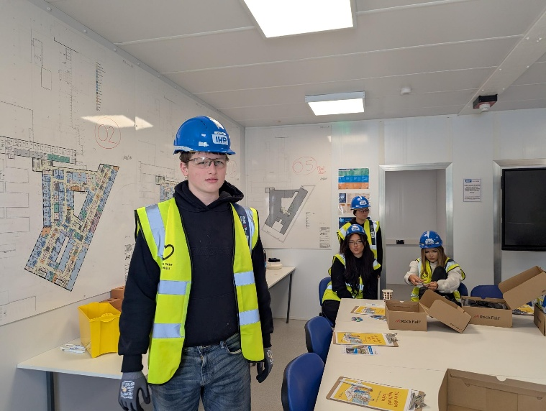
Learners had a fantastic opportunity to attend an exciting experience with Vinci Construction and Shrewsbury Hospital on Wednesday.
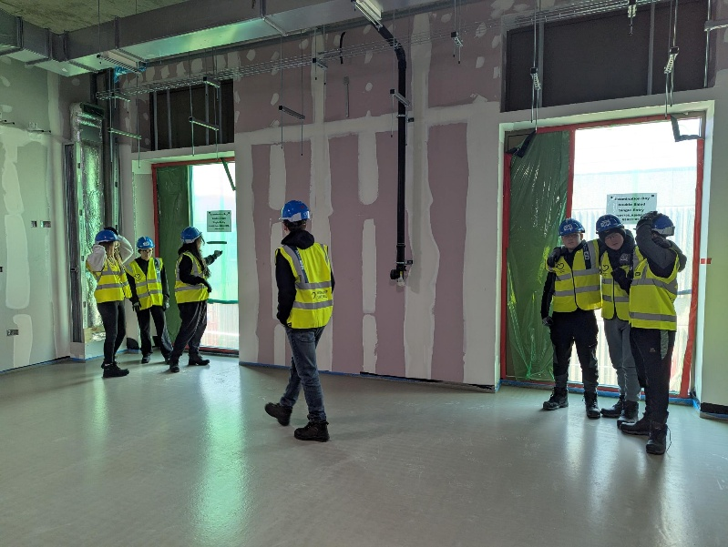
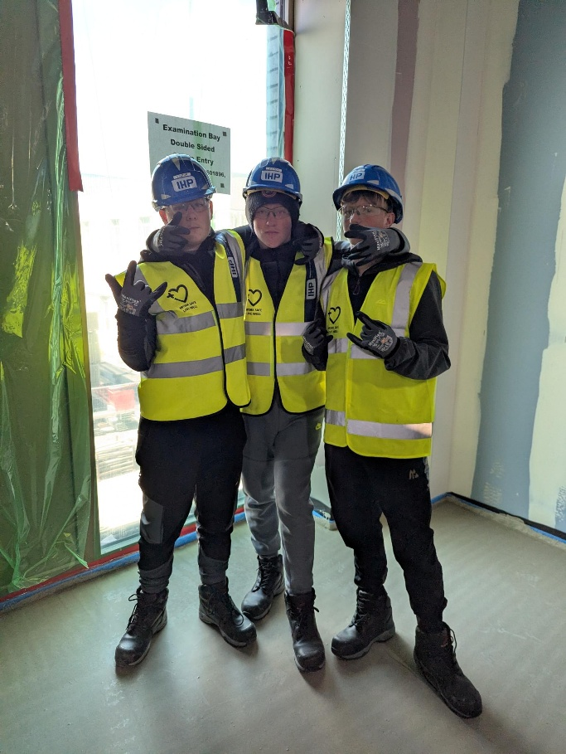
This interactive session introduced learners to the world of careers in

construction, combining practical activities with academic insight to inspire future pathways.

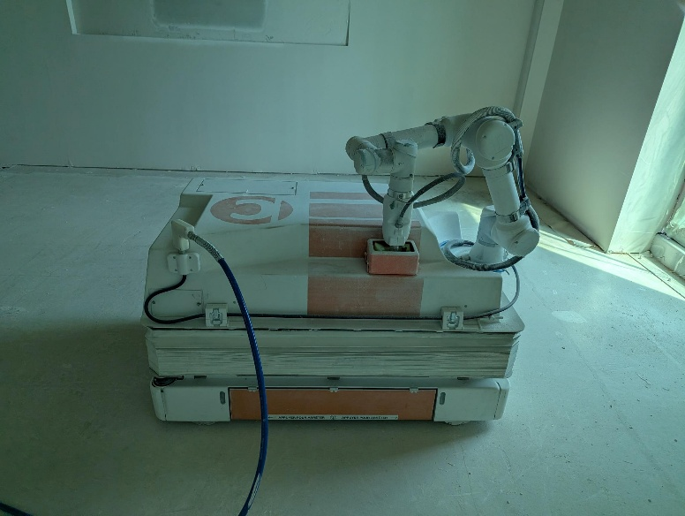
Delivered by Vinci, all activities took place at Shrewsbury Hospital,
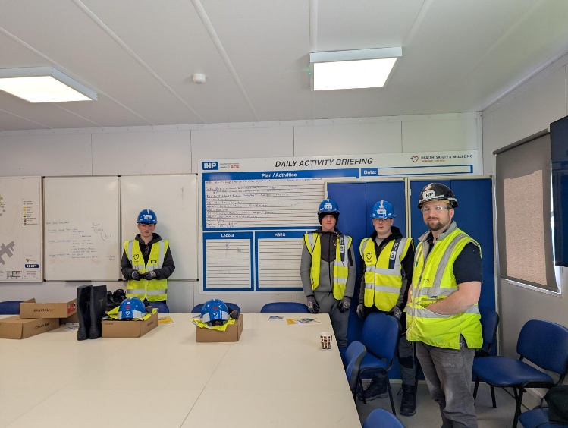
giving learners the unique experience of learning on a live hospital site.

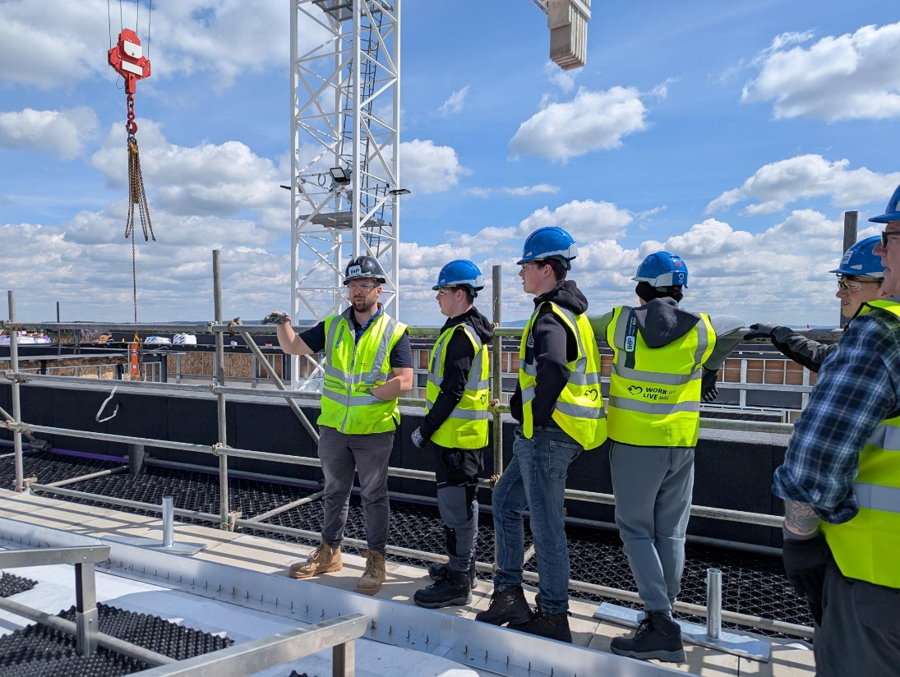

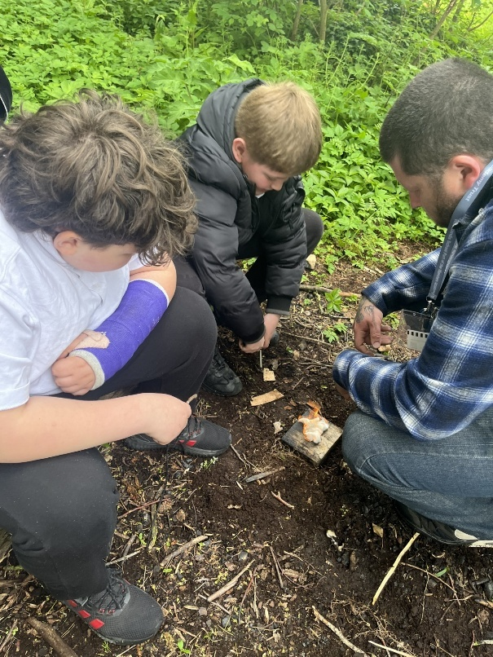
Acorns 3 had a brilliant time outdoors, striking flint and steel to make real sparks fly just like in Minecraft.

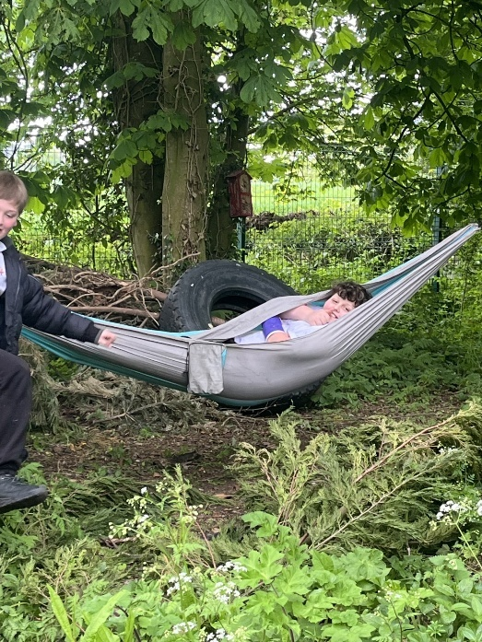
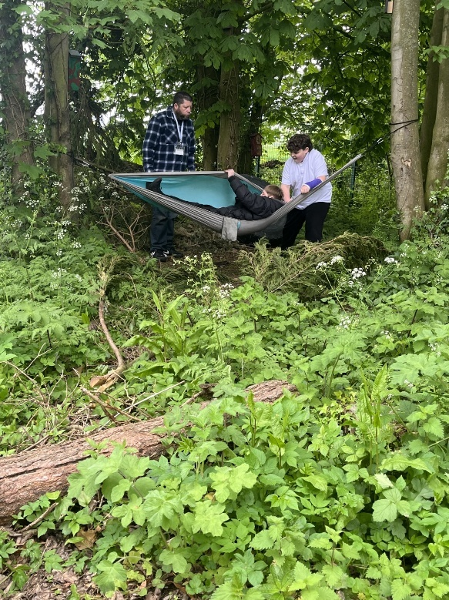
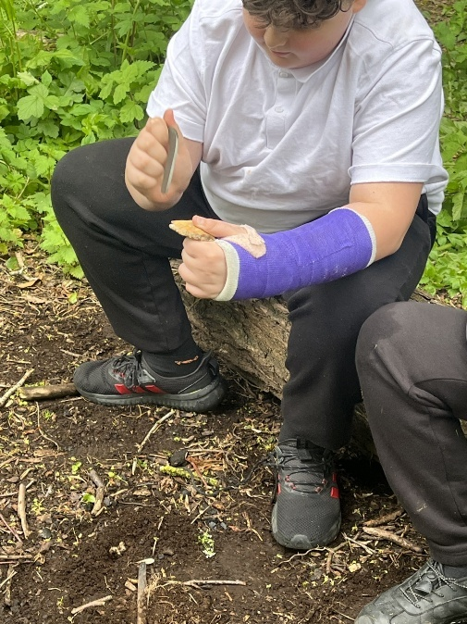
After getting their fire going, they relaxed in a hammock between two trees, enjoying a peaceful sway in the woods.
- Sian

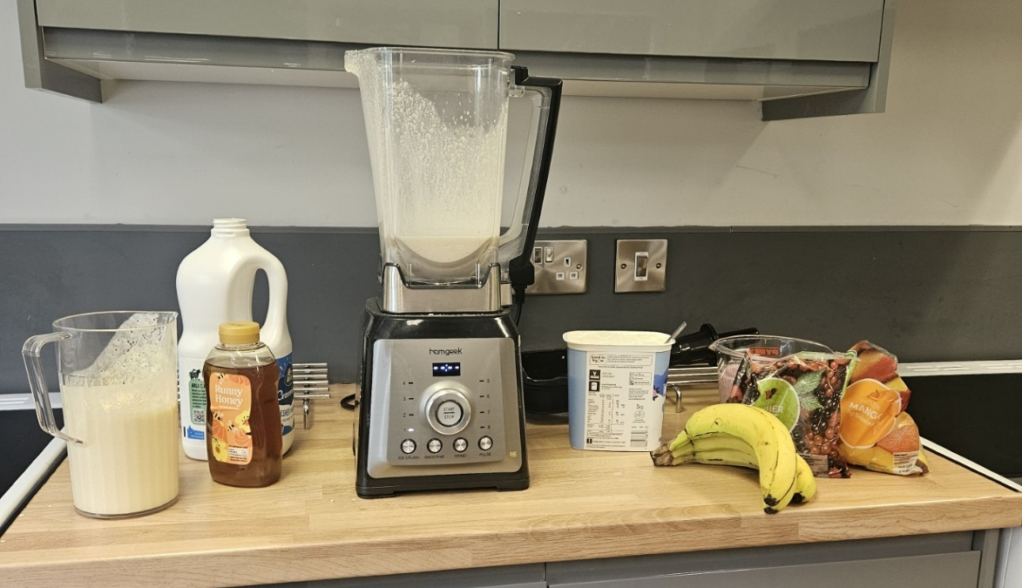

Saps 3 made smoothies in Catering. They experimented with taste and texture and learnt about nutrition.

- Anna D

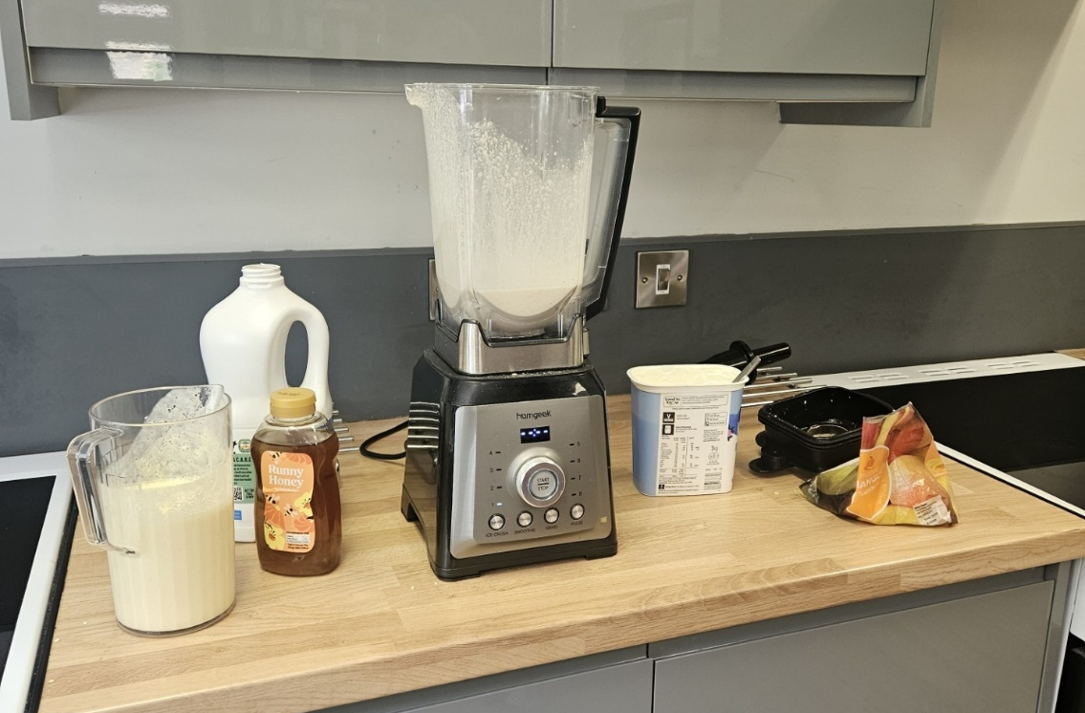

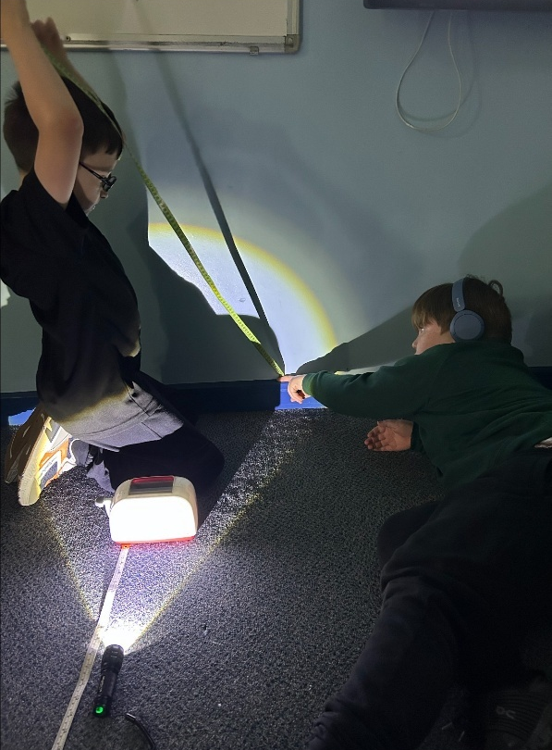
Spotlight on Acorns 2

Science: Acorns 2 explored how shadows are formed by using torches and opaque objects. They investigated how different shadows are created and practised measuring their height, developing their observation and enquiry skills.

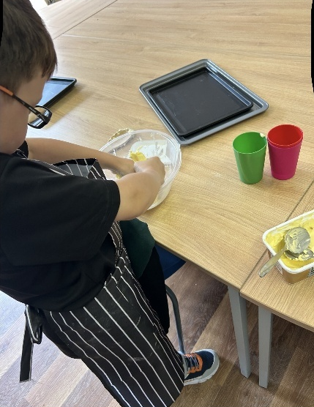
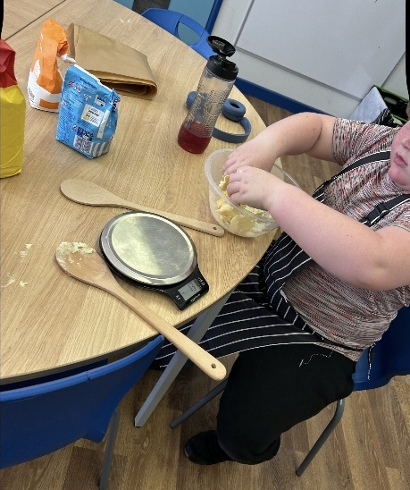
Cooking: Acorns 2 baked a delicious treat this week, practising important kitchen skills while making cookies.

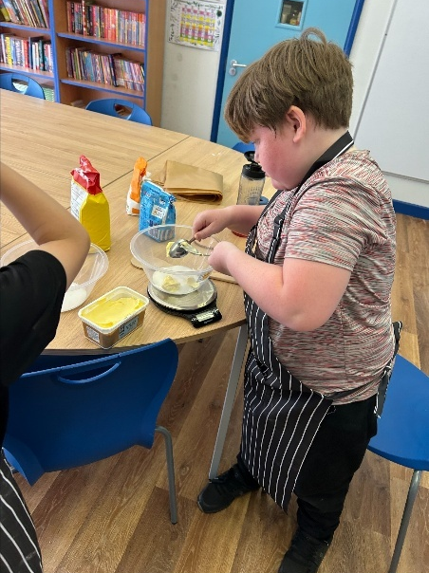
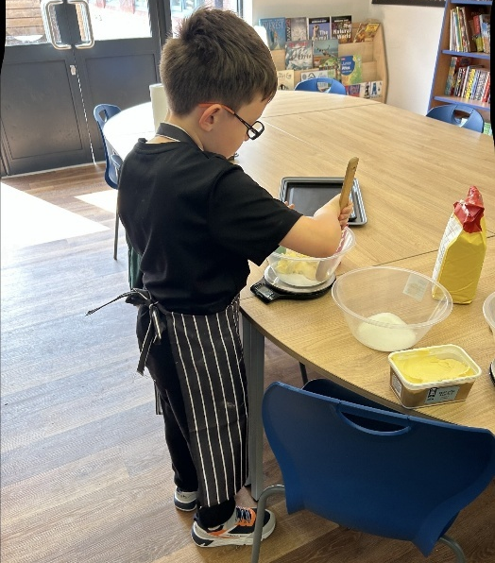

VE Day: OC supported Natalie in delivering a VE Day assembly to Acorns 2. Ollie also shared valuable insight into what life was like during the war, helping learners deepen their understanding of this important historical event.

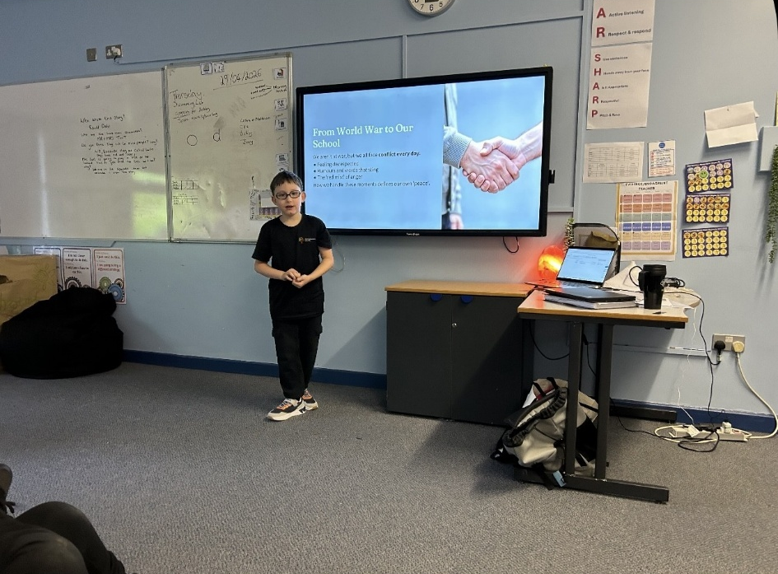

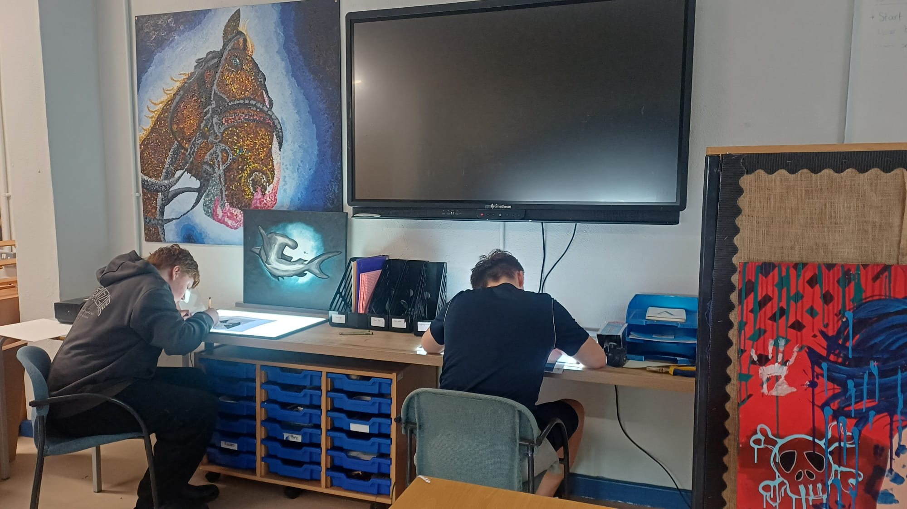

Saplings 1 have been enjoying the newly refurbished art room this week. They have been using light box boards to support their artwork, working with great focus and concentration while exploring their creativity.

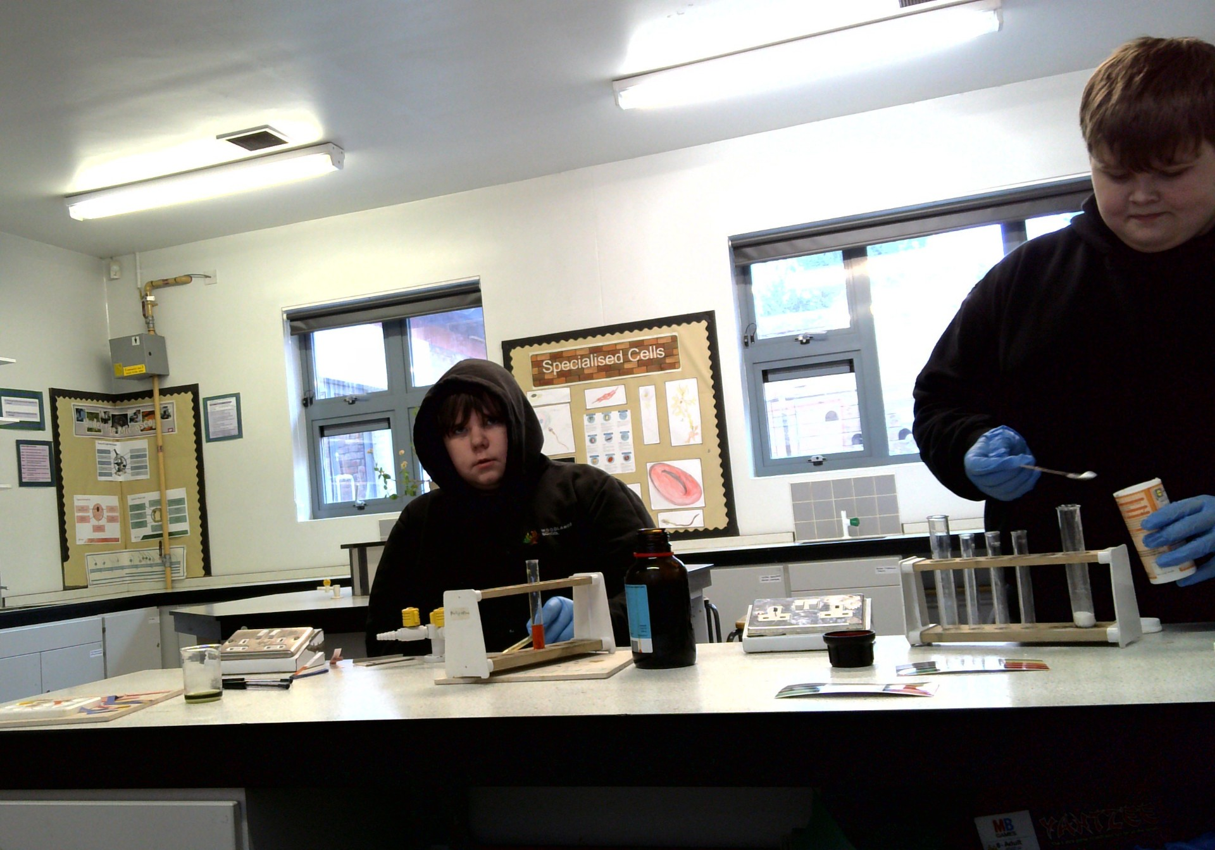
Leo and Jayden took part in a science lesson where they explored acids and alkalis. They worked together to identify which everyday substances and foods are acidic or alkaline, developing their investigative and scientific vocabulary skills.
- Joseph

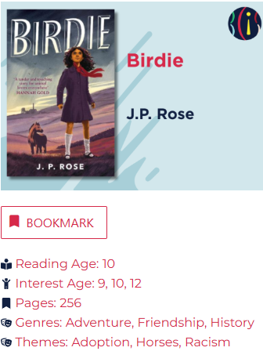
Book Club – Books of the Week
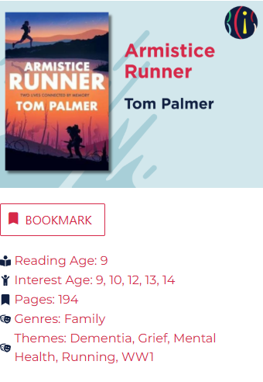

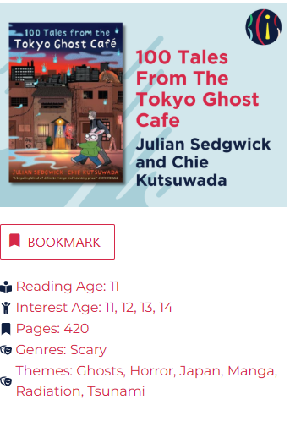


Each week learners will be able to win points in their lessons and for being their BEST. At the end of the week, the top learners who earn the most points will with win a prize!

The prizes will change every week, and every learner can have a chance to win.

This week’s winners are:
- Oscar
- Michael
- Thor
- Eliza
- Oliver W
- Ethan
- Leo Gi
- Lexi
- Charlotte

Well done everyone!
Keep up the hard work
and
remember that next time you could win!
Top 9 Learners!




Romeo showing Syrene and Matthew what he had learned on his guitar, he played music for us and explained how he had learnt it. Matthew and I were thralled it was beautiful - Syrene
Frankie made me laugh; Rocco completed a lesson alone when I asked. Destiny said she likes me being around. Charlotte showed me around the exercise equipment
P.S. Jules checked in on me – Matthew G

Jayden listened to advice and trusted adults to deal with a situation for him - Magz
Matthew used lovely manners when asking me to open the door – Magz
McKenzie had been really caring, walking into the Grange dining room, meeting all the staff and openly giving his brother a big hug in front of others
- Simon
Olly C helping on morning door duty - Magz
Rocco shining like a star, in my English lesson - Magz
Lacey DJ asked to do her Maths assessment - Alice
A spontaneous hug from Bobby, really made my day - Lisa

Dates for the Diary

- PCP Parents Evening
  - Online, by phone or in person
    - Thursday 9th July 3.30 – 5.30
    - Online, by phone or in person

- Mini Stick Golf Festival – Tuesday 19th May
- Mini Marathon – Friday 22nd May
- Secondary Sports Day – 20th July
    - Oswestry School – Full Day
- Primary Sports Day – 21st July
    - TBC location – Half Day
- Summer Fayre

Headteacher
Awards

- Arran for helping support his friends through the change of the classroom this week
- Zane for always being kind and patient

Core 5:
- Charlotte
- Eliza
- Ollie C

Power Up:
- Lexi
- Taylor
- Sophie

Lexia
Certificates
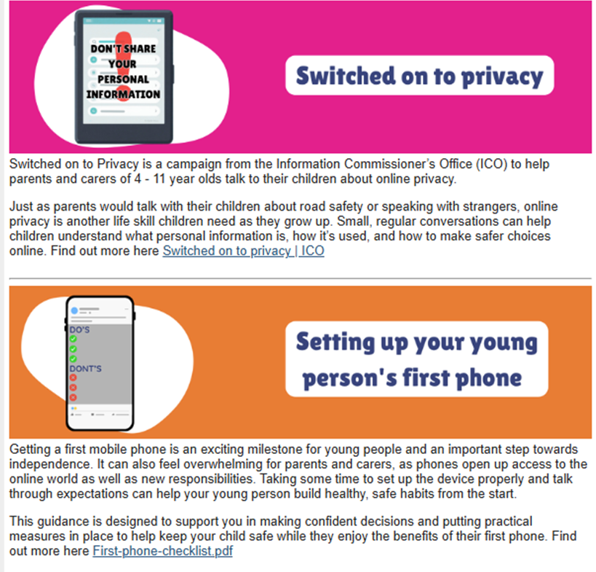
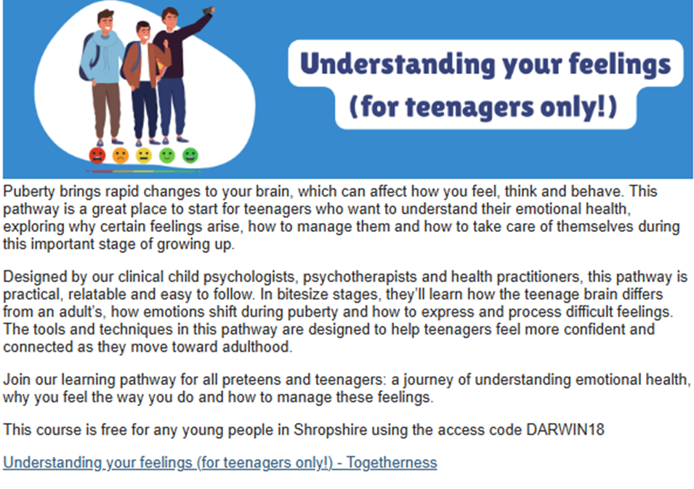
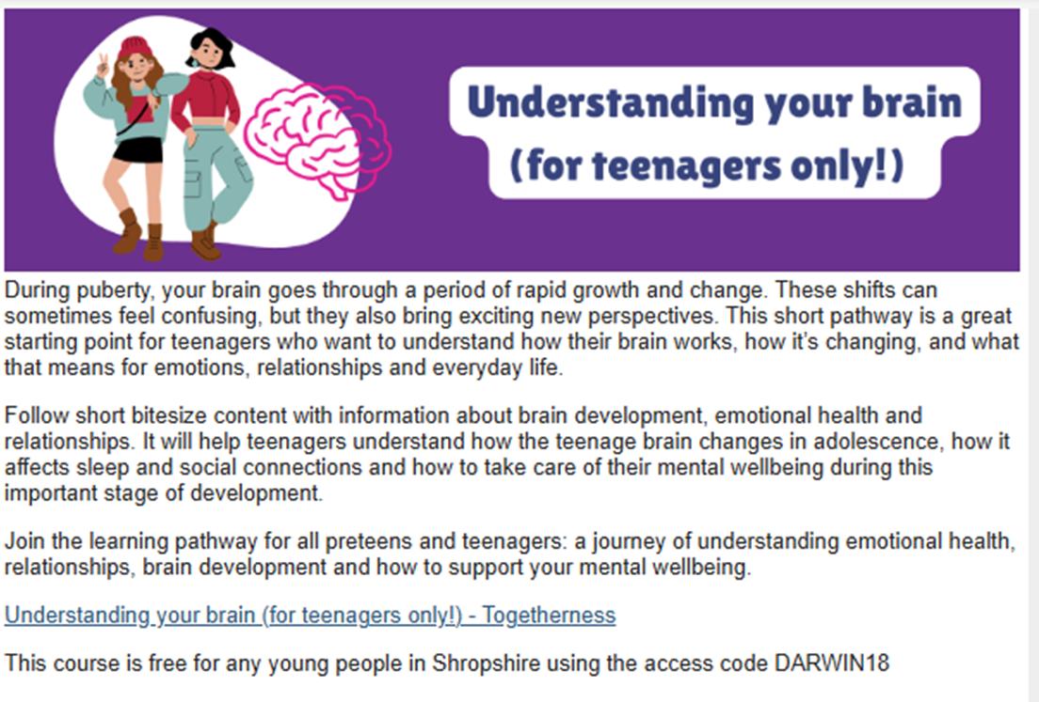
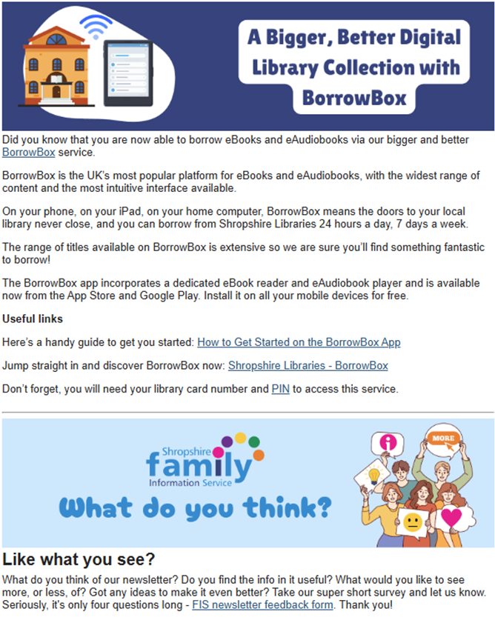



Why not follow us on Facebook
https://www.facebook.com/WoodlandsShropshire/

Or

Take a look at our website!

www.woodlands.school
Or
Join the conversation - We love hearing from you! Share your thoughts, questions, and suggestions with us.
rachel.bates@wdl.mmat.co.uk

If you need to contact us out of normal school hours, please either email on the above address
or call Rachel Bates on 07967 763324

Sending an Email to the Safeguarding Team

safeguarding@wdl.mmat.co.uk

- If you have any worries Parents/Carers or Students, please email the above address.

- Students, you can use your school accounts or personal email addresses.



