
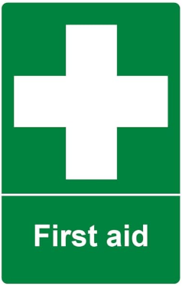
Woodlands school and all of its staff are committed to the highest standards in protecting, safeguarding and promoting the welfare of all our learners entrusted to our care.
If you have any safeguarding concerns, please discuss them immediately with anyone of our Designated Safeguarding Leads.

Safeguarding and Support for Learners
First Aiders in School
If you require medical help, please refer to the following members of staff:
- Ben Cameron
- Gareth Lewis
- Rachel Bates

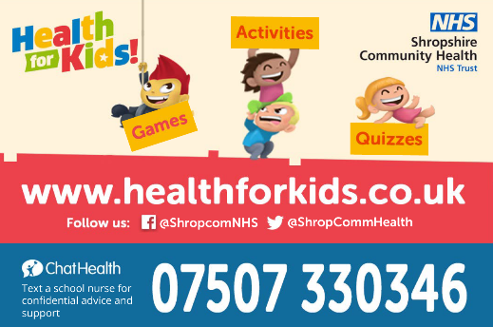
First Aiders at Woodlands
If you require medical help, please refer to the following members of staff
- Ben Cameron
- Gareth Lewis
- Rachel Bates
- Lisa Dugmore
- Elaine Downes
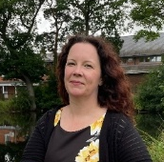  Jules Taylor  DSL  Headteacher |   Schmize Badger  DSL  Senior Lead for Learner Welfare |  |   Chloe McInnis  DSL  Director of Safeguarding |  |   Alice Arnold  DDSL  Deputy  Headteacher |  |   Simon Clay  DDSL  Senior Lead for Engagement
  Maddy Newman DDSL  Assistant Headteacher, Primary |  |   Sarah McLaughlin  DDSL  Director of SEND |  |   Ben Cameron  DDSL  PE Teacher |  |   James Trigg  DDSL  Teacher
  Hannah Shepherd  DDSL  LDAM |  | 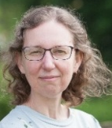  Rachel Bates  DDSL  Director of Data & Communications |  |   Archie Longville  DDSL  Risk Reduction Mentor |  |   Hayley Wilson  DDSL  Director of Early Help
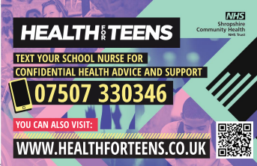
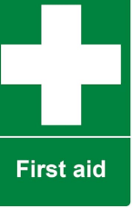
If you ever feel unsafe or need somebody to talk to, a member of our safeguarding team will always listen to you and make sure that you get the support you need.
You can get further information ask questions or simply contact our School Nurse
for a chat by texting the above number

Drop-in service at school for all learners
Kelly Gregg
Our school nurse will be available
dates and times on the weekly notices
Young Carers
If you feel you might be a young carer or wish to talk to someone about this contact anyone of the Designated Safeguarding Leads
Sending an Email to the Safeguarding Team
safeguarding@wdl.mmat.co.uk
- If you have any worries, you can email this address

- Learners, you can use your school accounts or personal email addresses.

