Woodlands Careers Programme 2025/6
Our progressive careers programme is designed to build through key stage 3 and 4 to facilitate a supportive “careers learning journey” to help our learners set ambitious life goals and move securely through education into a positive next step destination of their choice.
We have used the CDI learning outcome framework to be clear about our intended outcomes set within stages of career learning development and seek to deliver our programme via a mixture of embedded and discrete activity.
The stage of careers learning development that we use are:
Introduce Inspire Investigate Explore Apply & Demonstrate

Introduce | Inspire |  | Investigate |  | Explore |  | Apply & Demonstrate
Key Stage 3 |  |  |  |  | Key Stage 4
Year 7 |  | Year 8 |  | Year 9 | Year 10 | Year 11

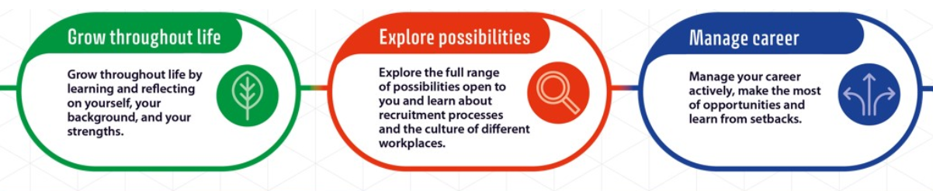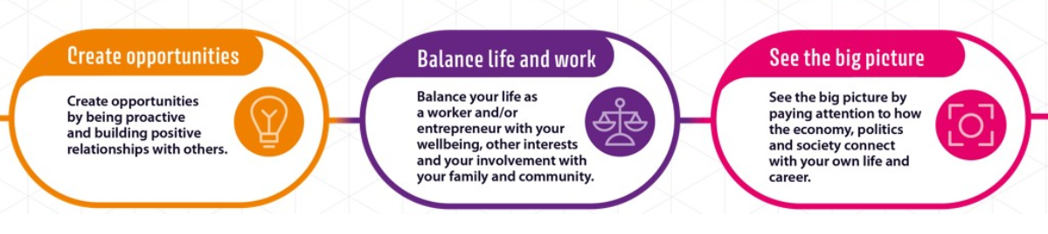

YEAR 7 Learning Outcomes | Relevant element of whole school careers programme
YEAR 7 Learning Outcomes | PSHCE programme content | Discrete Careers programme activity | Curriculum led content | Opportunities to differentiate for specific groups. (most able, risk of NEET, SEND, career interest led)
I can say what I like and am good at.   | Dreams and Goals PSHE lessons – What are my dreams and goals and Achieving my dreams and goals lessons (lessons 1 and 2) |  | English lesson during careers week summer 2 | Risk Reduction mentoring programme
I can talk about different job roles   | Celebrating difference PSHE lesson - Challenging stereotypes (lesson 3) | Experience of the workplace visit to Attingham Park, National Trust.  National Careers week activities – Branch activities | Non-core lesson during careers week autumn 1  Vocational lesson during careers week summer 1
I can name a careers website |  | ‘Information for students’ and LMI sections on the school website.  National Careers week activities – Branch activities | Maths lesson during careers week spring 2
I can say how school subjects link to different jobs.   |  | Careers fayre  National Careers week activities – Branch activities | Lesson Starters used in all curriculum areas in national careers week.  Science lesson during careers week autumn 2
I can set a target and talk about how well I have done.   |  |  | English lesson during careers week summer 2 | PCP target and Holistic Learner Profiles
I can talk about how we welcome visitors to school. |  | Careers fayre | Branch groups
I know who can help me in school. |  |  | Branch groups and Growth projects

YEAR 8 Learning Outcomes | Relevant element of whole school careers programme
YEAR 8 Learning Outcomes | PSHCE programme content | Discrete Careers programme activity | Curriculum led content | Opportunities to differentiate for specific groups. (most able, risk of NEET, SEND, career interest led)
I can use careers quizzes to build a profile of me. |  | National Careers week activities – Branch activities | Maths lesson in careers week autumn 1
I can talk about what I like and am good at. | Dreams and Goals PSHE lesson – Your long term goals (lesson 1) |  | English lesson in careers week spring 1
I can describe some essential skills for employment. | Dreams and Goals PSHE lesson – Your long term goals (lesson 1) | Work Place experience with Wolves foundation at Telford college | Science lesson in careers week summer 1
I can talk about the skills I am learning in my different lessons, and how I could use those in a job role. |  | National Careers week activities – Branch activities | Lesson Starters used in all curriculum areas in national careers week.  Vocational lesson in careers week spring 2
I can say what I think a ‘career’ is.   |  | Careers fayre
I can talk about the job roles that visitors do |  | Careers fayre
I can use lots of different careers websites to research careers. |  | National Careers week activities – Branch activities
I can talk about stereotypes and discrimination |  | Careers fayre | Non-core lesson in careers week summer 2
I can keep a careers diary. |  | On going Branch focus

YEAR 9 Learning Outcomes | Relevant element of whole school careers programme
YEAR 9 Learning Outcomes | PSHCE programme content | Discrete Careers programme activity | Curriculum led content | Opportunities to differentiate for specific groups. (most able, risk of NEET, SEND, career interest led)
I can use lots of different websites to research my favourite careers. |  | National Careers week activities – Branch activities | Non-core careers lesson in summer 1
I can explain what I have learned about careers to others. |  | National Careers week activities – Branch activities | Non-core careers lesson in summer 1
I can talk about what employers want, and how my own skills and qualities match that. |  | Careers fayre
I can talk about networking with visitors to school. |  | Careers fayre
I can explain how I boost my skills for the future with extra activities. |  |  | Science lesson in careers week summer 2
I can explain how I boost my understanding of the world of work through an experience of the workplace. |  | Work Place experience with Wolves foundation at Telford college
I can say what I have learned about how jobs and how that will help me. |  | Work Place experience with Wolves foundation at Telford college
I can use a job advert to see what the employer is looking for. |  |  | Lesson Starters used in all curriculum areas in national careers week.
I can say what I am good at and what I would like to get better at. | Dreams and goals PSHE lesson – my personal strengths (lesson 1) |  | Maths lesson in careers week autumn 2
I can explain what different key stage 4 courses involve and how that fits with what I am good at. |  | National Careers week activities – Branch activities
I can describe different qualifications |  | National Careers week activities – Branch activities | Vocational lesson in careers week spring 1
I can describe the different options after year 11. |  | National Careers week activities – Branch activities
I can write an action plan with an appropriate person in school. | Dreams and goals PSHE – the power of planning (lesson 2) |  | English lesson in careers week spring 2
I can describe what an entrepreneur is. |  |  | English lesson in careers week spring 2

YEAR 10 Learning Outcomes | Relevant element of whole school careers programme
YEAR 10 Learning Outcomes | PSHCE programme content | Discrete Careers programme activity | Curriculum led content | Opportunities to differentiate for specific groups. (most able, risk of NEET, SEND, career interest led)
I can talk about how the job roles I like are a good fit for me. |  | National Careers week activities – Branch activities  Mock interviews | English lesson in careers week autumn 1
I can talk about the skills for work I am learning in my different lessons. |  | National Careers week activities – Branch activities  Mock interviews | Lesson Starters used in all curriculum areas in national careers week.
I can talk about jobs which are growing and shrinking. |  |  | Options lesson in careers week summer 2 | LMI assembly/workshop
I can name some employers in our area  . |  | Workplace visit with Vinci construction site at Shrewsbury hospital | Non-core lesson in careers week spring 2 | LMI assembly/workshop
I can tell you what ‘skills shortage’ means. |  |  | Maths lesson in careers week summer 1 | LMI assembly/workshop
I can write a CV |  | WEX | English lesson in careers week autumn 1
I can fill in an application form |  | WEX | English lesson in careers week autumn 1
I can talk about health and safety at work. | Celebrating difference PSHE lesson – equality in the workplace (lesson 2) | WEX | Vocational lesson in careers week autumn 2
I can use the internet or ask questions to find out more about a workplace or business that I am going to visit. |  | WEX | Options lesson in careers week summer 2
I can reflect on my work experience and explain what I have learned. |  | WEX
I can prepare questions to ask |  | Mock interviews
I can set targets. |  |  | Non-core lesson in careers week spring 2
I can talk about my ideas |  | Mock interviews
I can talk about different post-16 and post-18 options. |  | National Careers week activities – Branch activities | Science lesson in careers week spring 1

YEAR 11 Learning Outcomes | Relevant element of whole school careers programme
YEAR 11 Learning Outcomes | PSHCE programme content | Discrete Careers programme activity | Curriculum led content | Opportunities to differentiate for specific groups. (most able, risk of NEET, SEND, career interest led)
I can use open events and taster sessions to help me make decisions |  | CEIAG sessions |  | College visits supported by school staff
I can discuss what I have learned at open events and taster sessions |  | CEIAG sessions |  | College visits supported by school staff
I can evaluate the different options |  | CEIAG sessions |  | College visits supported by school staff
I can talk to a careers adviser about my choices and think about the options carefully. |  | CEIAG sessions
I can explain what qualifications I would need for each option and apply. |  | CEIAG sessions
I can identify ‘extras’ that will help me in the future. | Dreams and goals PSHE lesson – dreams, goals and skill set (lesson 3) | CEIAG sessions
I can explain how the ‘extras’ will help | Dreams and goals PSHE lesson – dreams, goals and skill set (lesson 3) | CEIAG sessions
I can talk about careers related news stories with others. |  |  | Lesson Starters used in all curriculum areas in national careers week.
I can discuss practical and financial aspects of different choices. | Dreams and goals PSHE lesson – money and debt (lesson 2) | CEIAG sessions | Vocational lesson in careers week autumn 1
I can discuss social media and careers. | Being me in my world PSHE lesson – Me, the internet and the law (lesson 4) |  | Non-core lesson in careers week spring 1
I can keep a full record of my careers and enterprise activity. |  |  | English lesson in careers week autumn 2
I can reflect on my experiences of workplaces |  | CEIAG sessions  Workplace visit with Vinci construction site at Shrewsbury hospital
I can explain how to apply for an apprenticeship, part time job or college course |  | CEIAG sessions |  | College visits supported by school staff
I can take the steps needed to make applications of my choice. |  | CEIAG sessions |  | College visits supported by school staff

